CREDIT RISK & LOAN DEFAULT ANALYTICS
Understanding borrower risk and default patterns

Data Analytics Project
Tools: Excel | SQL | Python | Power BI

1. Project Overview:
Credit Risk & Loan Default Analytics is a data analytics project focused on identifying borrower characteristics and loan-related factors associated with loan defaults. The project analyses borrower demographics, income, employment, loan characteristics, credit history, and previous default behaviour to uncover patterns in credit risk. The analysis was performed using Excel, SQL, Python, and Power BI, with the final insights presented through an interactive Power BI dashboard.
2. Business Problem:
“Which types of borrowers are more likely to default on their loans, and what factors should a bank consider when managing credit risk?”
3. Tools & Technologies:
Tool | Purpose
Microsoft Excel | Data inspection, cleaning, KPI calculations and exploratory analysis
SQL (MySQL) | Data querying, filtering, grouping and aggregation
Python (Pandas) | Data cleaning, validation and exploratory analysis
Power BI | DAX measures, data visualization and dashboard creation

4. Dataset:
The dataset contains 32,576 loan records and 12 key features after data cleaning.
Key fields include:
- Person age
- Person income
- Employment length
- Home ownership
- Loan intent
- Loan grade
- Loan amount
- Loan interest rate
- Loan status
- Loan-to-income ratio
- Previous default history
- Credit history length

5. Data Cleaning & Preparation:
The dataset was inspected for missing values, duplicate records, and data-quality issues before analysis. Missing values in the loan interest rate field were handled using the median interest rate. Missing employment-length values were retained as Unknown. The dataset was also reviewed for anomalous age values. Additional analytical columns were created to support borrower and loan segmentation.
Key preparation steps:
- Checked the dataset for missing values and data-quality issues.
- Filled missing loan interest rate values using the median value of 10.99.
- Retained missing employment length values as Unknown.
- Reviewed anomalous age records identified during data-quality checks.
- Created Loan Amount Band categories.
- Created Age Group categories.
- Created Income Group categories.
- Prepared the cleaned dataset for Excel, SQL, Python and Power BI analysis.

6. Analysis & Methodology:
The cleaned dataset was analysed using Excel, SQL, Python, and Power BI to identify patterns associated with loan defaults. The analysis focused on borrower characteristics, loan attributes, and previous credit behaviour.
Analysis performed:
- Calculated key portfolio KPIs such as total loans, defaulted loans and default rate.
- Compared default rates across loan grades.
- Analysed default rates by income groups.
- Studied the relationship between previous default history and loan defaults.
- Compared default rates across home ownership categories.
- Analysed default patterns by loan intent.
- Created loan amount, age and income segments.
- Used SQL and Python/Pandas for data analysis and validation.
- Used Power BI to visualize the major risk patterns.

Overall Workflow:
Raw Dataset → Data Cleaning → Excel/SQL/Python Analysis → Power BI → Insights → Recommendations

7. Power BI Dashboard:
An interactive Power BI dashboard was created to provide a concise view of the loan portfolio and highlight major default-risk patterns.
Key Performance Indicators:
- Total Loans: 33K
- Defaulted Loans: 7.1K
- Overall Default Rate: 22%
Dashboard Visuals:
- Default Rate by Loan Grade
- Default Rate by Income Group
- Default Rate by Previous Default History
- Default Rate by Home Ownership
- Default Rate by Loan Intent
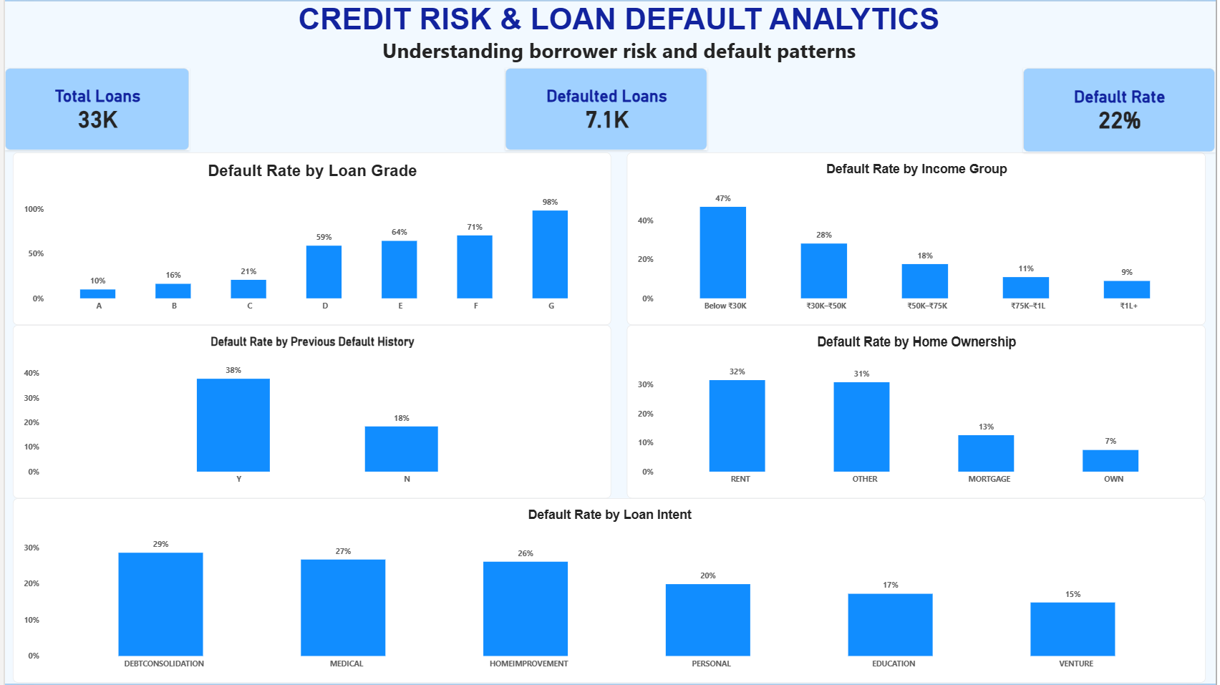

8. Key Business Insights:
1. Loan Grade: Default risk increases sharply as loan grade worsens, from 9.96% for Grade A to 98.44% for Grade G.
2. Income: Borrowers earning below ₹30K show a 47.01% default rate, compared with 8.93% for borrowers earning ₹1L+.
3. Previous Default History: Borrowers with a previous default have a 37.81% default rate, compared with 18.40% for those without previous defaults.
4. Home Ownership: Renters have a 31.58% default rate, while owners have 7.47% and mortgage holders have 12.57%.
5. Loan Intent: Debt consolidation has the highest default rate among loan purposes at 28.59%, while venture has the lowest at 14.82%.
Overall Finding:
Credit risk is not driven by a single factor. Loan grade, income, previous credit behaviour, home ownership, and loan purpose together provide useful signals for identifying higher-risk borrower segments.

9. Business Recommendations:
- Strengthen assessment for higher-risk loan grades: Apply stricter credit evaluation and risk-based lending decisions for lower-grade borrowers.
- Assess repayment capacity for low-income borrowers: Give additional attention to income, existing obligations and affordability.
- Use previous default history: Consider past repayment behaviour as an important factor when evaluating new loan applications.
- Monitor higher-risk borrower segments: Include housing status and other borrower characteristics as part of the overall risk assessment.
- Closely evaluate debt-consolidation loans: Examine existing debt obligations and repayment capacity more carefully for these applications.
Overall Recommendation:
Banks should use multiple borrower and loan characteristics together to develop a more effective credit-risk assessment strategy rather than relying on a single factor.

10. Conclusion:
This project analysed loan and borrower data to identify patterns associated with loan defaults. The analysis showed that loan grade, income level, previous default history, home ownership, and loan purpose are important factors associated with credit risk. By combining Excel, SQL, Python, and Power BI, the project transformed raw loan data into meaningful business insights and recommendations that can support more informed credit-risk assessment.

